Packet Tracer – Skills Integration Challenge

1. Topology

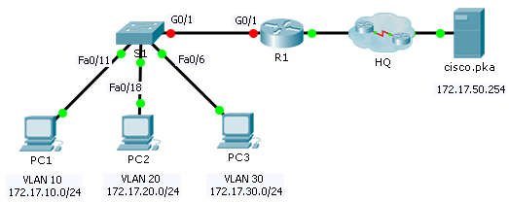

Addressing Table

|  |  |  |  |  |
| --- | --- | --- | --- | --- |
| Device | Interface | IP Address | Subnet Mask | Default Gateway |
| R1 | G0/0 | 172.17.25.2 | 255.255.255.252 | N/A |
| G0/1.10 | 172.17.10.1 | 255.255.255.0 | N/A |
| G0/1.20 | 172.17.20.1 | 255.255.255.0 | N/A |
| G0/1.30 | 172.17.30.1 | 255.255.255.0 | N/A |
| G0/1.88 | 172.17.88.1 | 255.255.255.0 | N/A |
| G0/1.99 | 172.17.99.1 | 255.255.255.0 | N/A |
| S1 | VLAN 99 | 172.17.99.10 | 255.255.255.0 | 172.17.99.1 |
| PC1 | NIC | 172.17.10.21 | 255.255.255.0 | 172.17.10.1 |
| PC2 | NIC | 172.17.20.22 | 255.255.255.0 | 172.17.20.1 |
| PC3 | NIC | 172.17.30.23 | 255.255.255.0 | 172.17.30.1 |

1. VLAN and Port Assignments Table

|  |  |  |
| --- | --- | --- |
| VLAN | Name | Interface |
| 10 | Faculty/Staff | Fa0/11-17 |
| 20 | Students | Fa0/18-24 |
| 30 | Guest(Default) | Fa0/6-10 |
| 88 | Native | G0/1 |
| 99 | Management | VLAN 99 |

1. Scenario

In this activity, you will demonstrate and reinforce your ability to implement inter-VLAN routing, including configuring IP addresses, VLANs, trunking and subinterfaces.

1. Requirements

* Assign IP addressing to **R1** and **S1** based on the **Addressing Table**.
* Create, name and assign VLANs on **S1** based on the **VLAN and Port Assignments Table**. Ports should be in access mode.
* Configure **S1** to trunk, allow only the VLANs in the **VLAN and Port Assignments Table**.
* Configure the default gateway on **S1.**
* All ports not assigned to a VLAN should be disabled.
* Configure inter-VLAN routing on **R1** based on the **Addressing Table**.
* Verify connectivity. **R1**, **S1**, and all PCs should be able to ping each other and the **cisco.pka** server.